Work Modes:

* Single Data Input
* External Temperature Input
* DSC only
* Full Course Meal

Simple Data Input – Temperature data combined with stress/strain data on the same time series

Requires data column selection

Requires data spike remover

Requires cross-sectional information

Requires strain input

Recommends slight moving average filter

Recommends data spiker remover enabled

External Temperature Input – Temperature data is on a separate time series from other data

Requires temperature selection column

Requires selection of data set to determine a shape memory cycle

Requires time sync function

DSC only

Requires DSC only

Full Course

Requires everything

Simple Data Input Mode – Temperature data combined with stress/strain data on the same time series

If you have one data set with temperature and displacement at a minimum, the following sections below are needed to properly analyze your data.

File Input

This is where you can input your raw data for processing. It supports .txt and .csv files. The importer will automatically detect column headers and provide them as options in the data selection menus. For this tool to work, only data with temperature and displacement is needed at a minimum in the Single Source option. It will automatically find time and load. Load will be automatically converted into stress later with the cross-section information.

A file in external temperature source will allow one to analyze their mechanical data with respect to an external thermocouple, for example. This option creates a potential issue with time synchronization. The data between the sources may not exactly on the same timeline, a thermocouple is off by 12 seconds of realtime, then it will throw off your data; or one dataset records in seconds from a start point don’t while the other one records in realtime. This is not a problem for SMA REACT! These aspects will be further explained in the Time Synchronization menu.

Single Input Data Selection

When you upload a compatible file in the File Input, REACT will read possible columns as your data input. You will have to manually select which column is temperature and which column is displacement. React will automatically detect which column is load and time. If REACT is not detecting the load and time or more, you will have to manually add a keyword in the source code.

Cross-Section Information

Cross-section information all calculate your stresses based on load from the data. There are few default cross-sectional profile shapes available, such as circle, square, rectangle, cintraquad, and a custom cross-sectional area can also be entered.

A cintraquad is a rectangular cross-section with a circular void. The name comes from “circle within a square” translated into Latin as “circulus intra quadrata”; a portmanteau of the Latin phrase can become cintraquad.

This function can also convert length-scale units, an input unit can be selected, and the output can be different from the input file itself.

Strain Calculation

In order to calculate strain from the displacement data, an original length of the material must be included. The units depend on the input unit of cross-sectional information.

Data Spike Remover – Future Custom Functions

Currently, we have a special data cleanup function that removes spurious zeroes, this is an issue with one of TAMU’s MTS machines. If you have spurious zeroes, this will remove them conveniently for you. In the future, this space will be for custom functions, where are few like that shown will be included too.

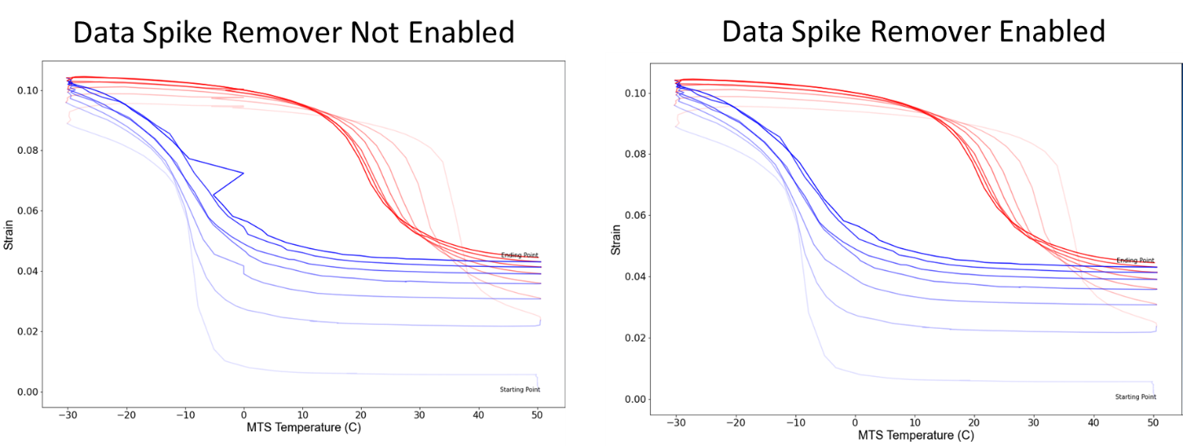

This shows the same dataset without and with the data spike remover function.

Moving Average Filter

It is recommended to try out the moving average filter. We recommend to put a slight to moderate moving average on temperature, displacement, and loading data by clicking the three respective checkboxes on the GUI. A slight moving average of 5 will take 5 datapoints and average out the values. This can remove noisy data and allow SMA-REACT to better determine where a cooling/heating curves start/end.

Generally, determining how many datapoints to average will depend on your analysis goals, data resolution, and noisiness. We help make this important selection faster by showing you the results of the moving average filter with respect to unfiltered data as well as in comparison to some data columns filtered but others remaining unfiltered, as seen in the two figure below.

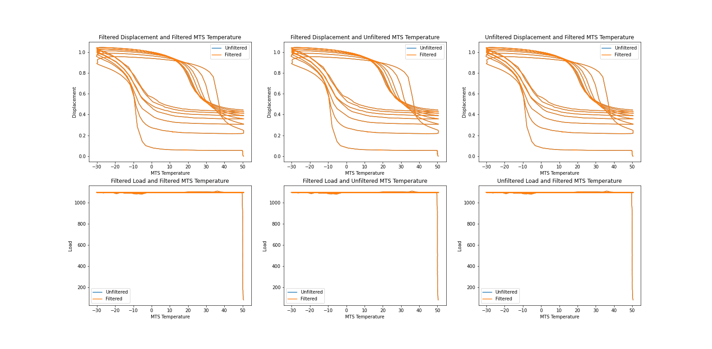

The data above has a moving average filter of 5 for temperature and displacement. The first graph on the left shows displacement and temperature in a filtered way, the middle figure shows filtered displacement but unfiltered temperature, while the right figure shows unfiltered displacement but filtered temperature. There is completely unfiltered data plotted with a blue line behind each of the various filters. One cannot distinguish between the unfiltered and the filtered in any mode of the filtering, showing that the data could be filtered more without compromising the actual values.

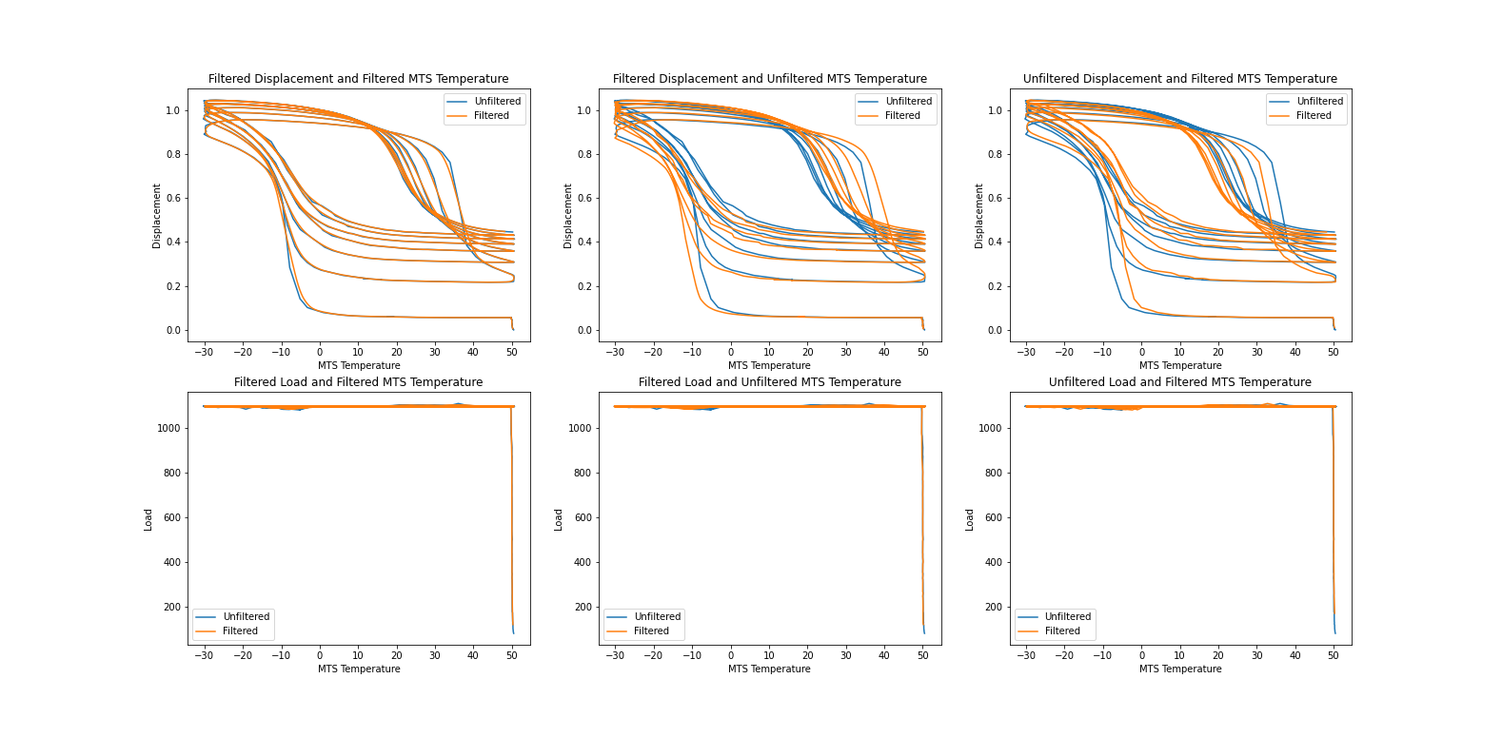

The data above has a moving average filter of 1000 for temperature and displacement. Now the blue line is somewhat noticeable for the dual filtered data on the left and extremely noticeable for the middle and right. The data on the left is probably safe to use as-filtered, as long as both axis are both being filtered; if one filters only temperature or only displacement, then there will be a significant shift in the true data!

Full example:

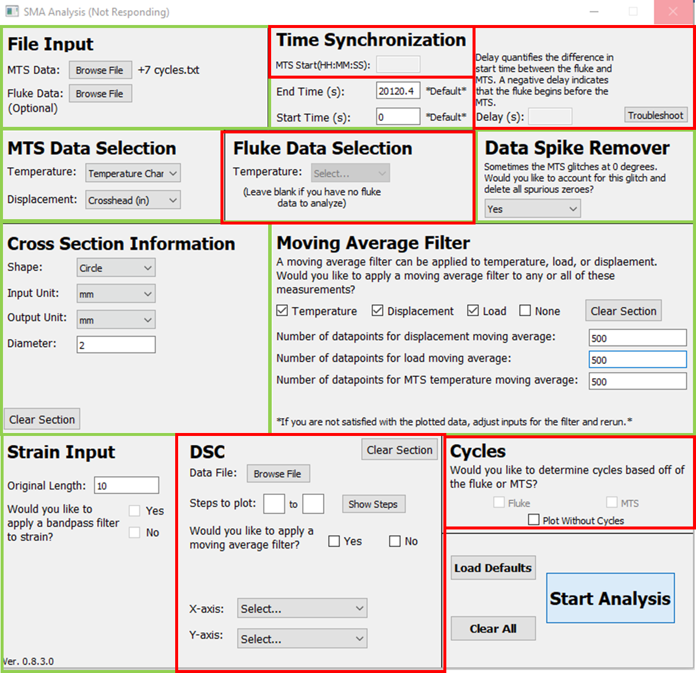

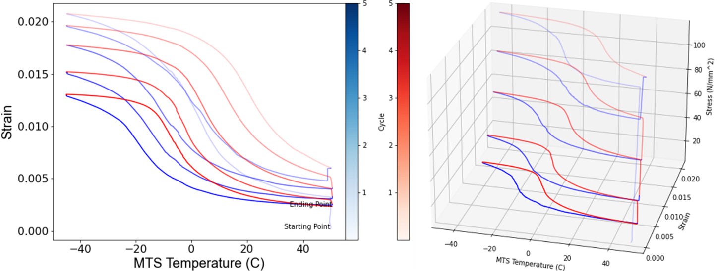

External Temperature Input Mode – Temperature data is on a separate time series from other data

All of the functions required in Single Input mode are required for External Temperature Input, in addition to External Temperature Data Selection, Time Synchronization, and Cycle Basis Selection. Temperature can be selected in both data inputs for comparisons.

External Temperature Data Selection

This function asks you to select which column is the temperature that you want to plot from the External Temperature Data.

Time Synchronization – Level 1 – I Know All Time Discrepancies

This section will save your bacon for a number of time series issues between multiple data sets. This function has multiple levels of complexity. It can resolve problems between:

* One dataset using realtime while the other uses time elapsed
* Datasets having different non-linear time intervals
* Data acquisition starting at the unknown elapsed time compared to another dataset
* Computers not showing the same realtime

The first level of complexity is what is shown above. After reading your input file, the start time will default to 0 seconds and the end time will default to the last time in the input, it will convert hours or minutes to seconds automatically. If you want to ignore the beginning or end of some dataset, this is the way to simply do it.

If you have the single input mechanical data recorded in a time elapsed style, then it is crucial to know at what realtime the data acquisition started, if you have realtime data with your external temperature dataset. If you know the delay between the external temperature data and mechanical data, then you can simply enter the delay in seconds and move on.

It is best practice to know:

* The realtime an elapsed time style dataset began,

and

* The differences between realtimes between two or more computers,   
  or
* The time differences between elapsed dataset starting their acquisition

Time Synchronization – Level 2 – I Know Where The Data Points Should Sync Up

Though the experimental world is messy and sometimes you are missing one or more of the above crucial information. SMA REACT allows you to quickly visualize potential time discrepancies and still make the most out of your data!

By clicking on the troubleshoot button, you will bring up another GUI to help you graphically determine where the two start points of your datasets are. After re-entering the data and selecting the correct columns, you can click on the data point of each data set where you think the beginning of the dataset should be. When you click on a point, there may be a few points in the vicinity of the click, the drop-down menu on below the graphs will allow to precisely select which point you want. When you are ready, you can click on Sync, and REACT will add a delay to the main GUI menu and close the troubleshooter.

If you are still unsure if the points you selected are correct, then you can hit test sync, to bring you to another menu.

Time Synchronization – Level 3 – I HAVE NO TIME DISCRPENCY INFORMATION

This level of troubleshooting is experimental. Here you can compare different delays on your datasets to see how they sync up for the entire run.

The left plot compares your mechanical data to the external temperature data. The simplest thing to do would be to adjust the slider or manually input a delay on the left.

The plot on the right compares the mechanical data with the temperature from the internal dataset. The right plot should be synced together naturally as it comes from the same dataset, however you can slightly adjust the time with the input delay box under the right graph.

Meanwhile, some very experimental features are to find intersection values for either plot. If you guess where an intersection is on the left and the right of a peak or trough, then give a minimal distance between the apparent intersection, it will calculate the true intersection values and give you an area between the curves, this value might help you determine what syncs up better.

The plot delay vs area feature will ask for the minimum and maximum delay between datasets would be and at what interval to check between, every 1 seconds, every 10 seconds, etc. Then it will plot area under the curves for those intervals. This might help one determine the correct delay, very experimental though! One can see an example plot below, in this dataset the correct delay is some local maxima, however, there are a few, which one makes the most sense? You would have to compare to the sync plot and know the logic of the experiment to help you make a final decision.

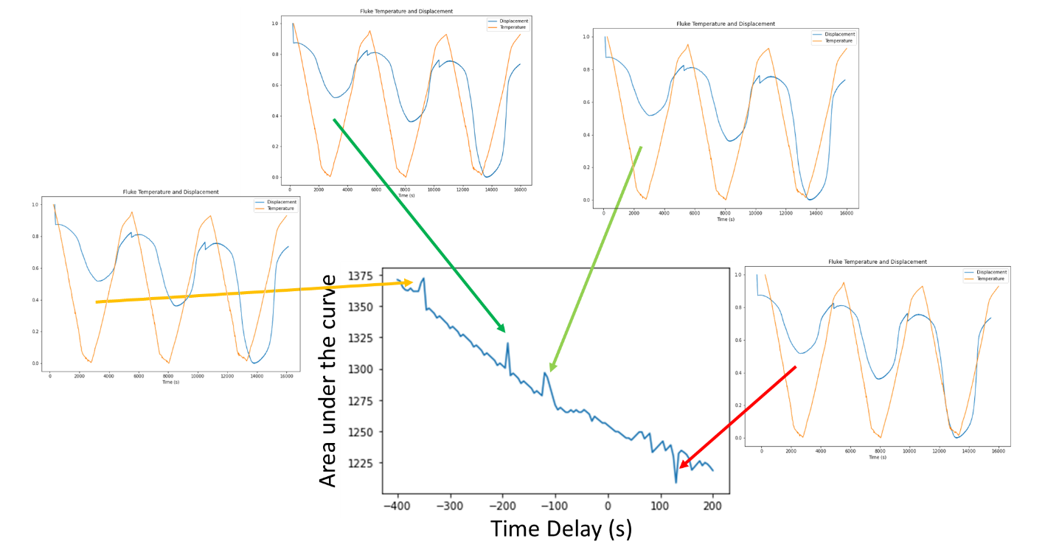

Meanwhile, one must be careful to not sync the data exactly concentric with respective peaks and troughs, such as the figure with the red arrow above. There is an inevitable thermal lag between the temperature recorded by a thermocouple or other technique and the mechanical response of the SMA. For example, a thermocouple or pyrometer measuring the surface of SMA will always reach the local maxima/minima temperature before the SMA’s displacement reaches a local maxima/minima. If they are concentric, then this means one had a temperature recording device within the center of the SMA itself, and some other physics were conveniently ignored!

Cycle Input Determination

This function simply asks if you want to determine a cycle based on the External Temperature Data or the Single Input. This is mostly used for troubleshooting. Further, one can remove the cycle determination completely in this section.

DSC Only Mode

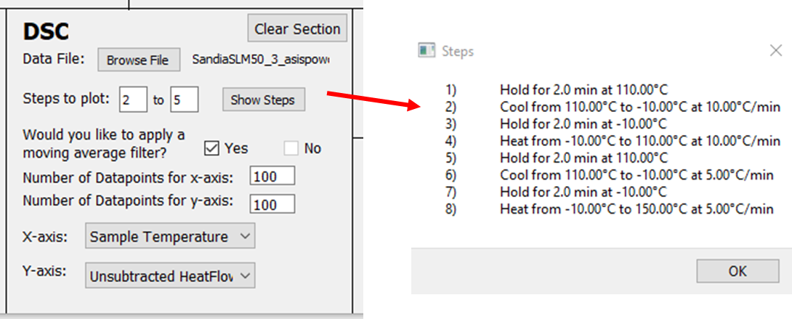

Ignoring all the modes and functions above, this function allows you to solo analyze differential scanning calorimetry data of an SMA. Input the file. Determine which steps of the DSC data you want analyzed, sometimes you want to ignore the first heating and cooling loop for example. Consider if you would to apply a moving average filter. Choose the respective data columns, typically temperature as the x-axis and heat-flow as the y-axis.

